Predict COVID-19 Hospital Patient Length of Stay using Random Forest – Executive Summary and Implications
Abhishek Khatti
Western Governors University

Contents
Contents 2
Statement of Problem and Hypothesis 4
Background of Study 4
Statement of Problem 4
Hypothesis 4
Null Hypothesis – H₀ 5
Alternative Hypothesis – H₁ 5
Raw Data Set 5
Summary of Data Analysis Process 6
Tool Selection and Processing Challenges 6
Data Collection, Extraction, and Processing 7
Feature Analysis and Engineering 11
Evaluation Metrics for Imbalanced Classification 14
Tests of Correlations & Associations 16
Custom Functions & Honest Assessment 17
Model Training & Hypothesis Testing 18
Hyper-Parameter Tuning & Balancing Imbalanced Response Classes 20
Performance Assessments of All Models 23
Outline of Findings 25
Exploratory Data Analysis of Independent Variables 25
Target Feature 25
Independent Features 26
Test of Correlations Among Continuous Variables 34
Test of Association Results 35
Model Training & Hypothesis Testing 36
Important Features & ROC Curve 39
Hyper-Parameter Tuning 40
Balancing the Imbalanced Response Classes 41
Bottom-line Performance Assessments of All Classification Models 42
Generating Final Output Data Frame 43
Limitations of the Study 45
Summary of Proposed Actions 46
Benefits of the Study 46
Acknowledgment 48
References 49

Predict COVID-19 Hospital Patient Length of Stay using Random Forest – Executive Summary & Implications

Statement of Problem and Hypothesis

Background of Study
The COVID-19 pandemic has placed an extraordinary strain on health care systems, with rapidly increasing demand for healthcare in hospitals and intensive care units (ICUs) worldwide. As the pandemic spikes, determining the needs for healthcare resources (beds, staff, equipment) has become a key priority for many countries. Projecting future demand requires estimates of how long patients with COVID-19 need different levels of hospital care.
The patient length of stay is one of the critical parameters to observe and predict if an improvement to the efficiency of the healthcare management in a hospital is to be made. This parameter helps hospitals to identify patients of a high length of stay risk (patients who will stay longer) at the time of admission. Once identified, prior knowledge of the length of stay of the patient being admitted can aid in logistics such as room, bed allocation, staff assignment, and PPE (Personal Protective Equipment) consumption planning. The problem is to manage the functioning of Hospitals professionally and optimally.

Statement of Problem
Given the multi-class nature of the response variable, the question being addressed is whether a Multi-Class Random Forest Classifier can be used to classify the length of stay of a particular patient case.

Hypothesis
A hypothesis test is to be performed to check whether a multi-class Random Forest classification model can be created to predict the probabilities of the length of stay classes.

Null Hypothesis – H₀
A Random Forest classification model cannot be used to predict patient Length of Stay class using the Hospitalization dataset.
The null hypothesis is that a random forest classification model cannot predict probabilities for target length of stay with 11 classes correctly i.e., the mean ROC-AUC score from Repeated Stratified K Fold Cross-Validation for random forest model on the validation data set is not more than 50%. If the mean AUC score is not more than 50%, then the predictive model cannot correctly distinguish between the classes and does not offer a justification for implementing this complex solution.

Alternative Hypothesis – H₁
A Random Forest classification model can be used to predict patient Length of Stay class using the Hospitalization dataset.
An alternative hypothesis to the null hypothesis is that the random forest classification model predicts the probabilities for target length of stay classes and correctly distinguishes between the classes, i.e., the mean ROC-AUC score from Repeated Stratified K Fold Cross-Validation for random forest model on the validation data set is significantly greater than 50%. If the mean AUC score is more than 50%, then the Random Forest model offers a better intuition to manage the hospital resources optimally and it justifies implementing this complex solution.

Raw Data Set
The data available is in a single file called “host_train.csv” and is downloaded manually from kaggle.com, where the uploader of the data set, Mobius has made this information publicly available on the Kaggle website (Mobius, 2020).
The file consists of a total of 318,438 rows, with 1 header row and 18 columns, including the target variable Stay_Days. The raw data contains information about the hospitals where the patients were treated, few patient demographic details, the type of admission for the case, and the categorical response variable with 11 classes of the length of stay. The “Stay_Days” column informs about the length of stay of a case. The Stay_Days response variable is a Multi-Class response variable. As explored further, the response variable has highly imbalanced categories.
Stay_Days
0-10
11-20
21-30
31-40
41-50
51-60
61-70
71-80
81-90
91-100
More than 100 Days

Summary of Data Analysis Process

Tool Selection and Processing Challenges
Based on recent research and feedback from customers from various industries and domains, Python is the first choice among various industry leaders for its versatility, a massive collection of open-sourced libraries, and easily scalable solutions (BurtchWorks, 2020).
In addition to using Python as a tool of choice, the workstation, or the environment where the Random Forest models are fit & tuned is also important, since lack of processing resources could impediment fitting decently accurate models. Notably, when the random forest model needs to be hyper-tuned, this poses a significant challenge to work with limited processing resources (Plonski, 2020). While some analysis of data is done locally on a workstation, to address this resource shortage on local workstations, the Azure ML node is utilized to fit & tune the models and perform most of the analysis. The Azure ML node used, also known as a “Compute”, has a configuration of 56GB RAM, 6 cores CPU, 1 GPU, and 380GB disk space.

Data Collection, Extraction, and Processing
The data set is limited by the accuracy and completeness of the information made publicly available by the uploader at Kaggle, and only contains patient stay details. Although the final model is to be used during the patient admission process only to forecast resource utilization and allocations, the data set does not include prior health history information for patients or the type of treatment the patient is receiving, which could influence the response to COVID-19 treatment for a specific case, which could result in a difference in predicted length of stay of a patient during admission compared to the actual stay.
The list of libraries used for analysis and predictive model building, along with their intended use in the Python program are:
- pandas – for file I/O, work with Dataframes, etc.
- numpy – work with numeric arrays and functions
- dtale – perform descriptive analytics on the raw data set
- matplotlib – for visualizations
- seaborn – for visualizations
- collections – using the Counter function to count items
- warnings – suppress future warning messages
- sklearn – Sci-kit library build machine learning models and perform predictive functionalities
- imblearn – to address the imbalanced data set
- statsmodels – perform a test of association using MNLogit model
- azureml – Specific to Azure ML node to load datasets into cloud node & run Azure specific tasks
- pingouin – Perform pairwise-Tukey post hoc analysis
The exploratory data analysis is performed both, locally and on the Azure ML node. To extract data in a local instance of Python, the read_csv function of Pandas library is used to load into a Pandas data frame.
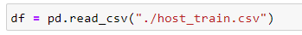
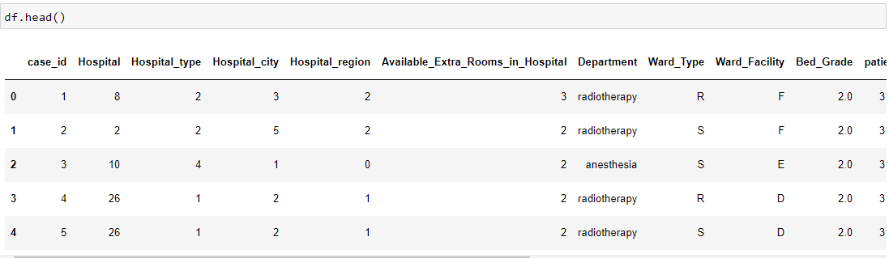
To extract data in the Azure ML node of Python, the data first must be registered as a “Dataset” within the cloud instance. The advantage of using this approach is that when the data is split into multiple different files, the data can be loaded into a single dataset, which can later be consumed as a single source of truth. For example, if a large data set is available as a combination of multiple files, loading into a data set in Azure simplifies data read operations, rather than working with complex code to stitch multiple files together. However, the disadvantage is that if there is a single file that is relatively small, this adds an added overhead to read it in data set format and then convert it to Pandas data frame. Here the data is loaded in a Dataset in Azure ML instance as “covid_los_raw” in the default workspace blob data store.
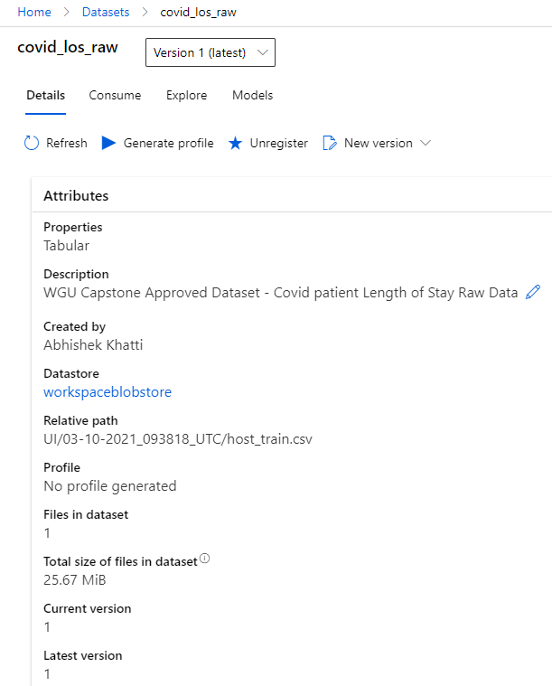
To extract the data into a Python notebook and convert it to Pandas data frame for analysis and model building, standard functions from the azureml library must be used, as shown below.
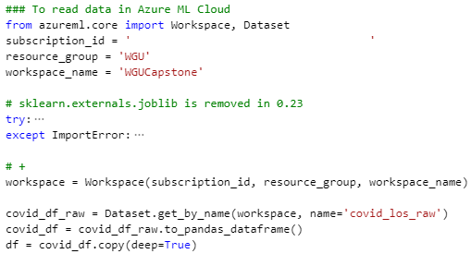
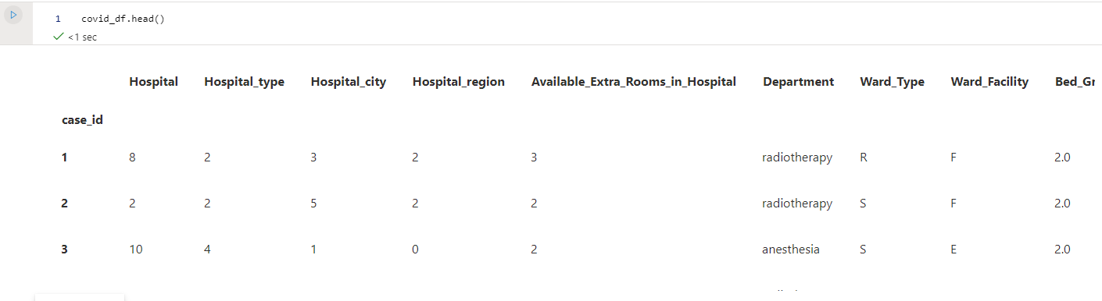
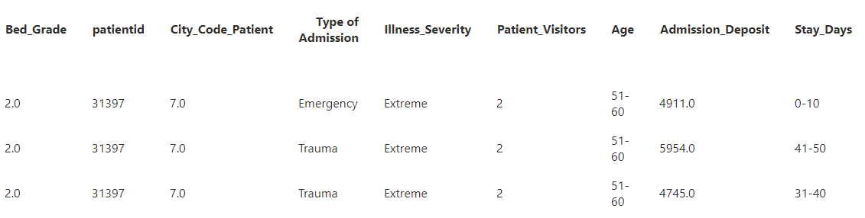
The data contains both categorical and continuous variables. Any entries that have missing inputs for any of the variables were removed since failure to remove the missing inputs can negatively impact the accuracy of the model (Sankara, 2018). Also, the overall data sparsity is approximately 1.46%. The variables Bed_Grade and City_Code_Patient have 113 and 4,532 entries respectively. After dropping the records with missing entries, the total number of records in the new dataset is 313,793.
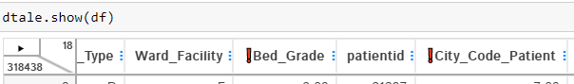
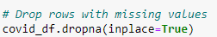
The categorical variables were transformed so model training algorithms can work with them. For example, Age is a categorical variable, which is Label Encoded from 0-10 to 0, 11-20 to 1, and so forth. None of the categorical variables were one-hot-encoded, since one-hot-encoding categorical variables result in worse accuracy scores for Random Forest models (Ravi, 2019). Although outliers exist within the data set, the records with outliers are not changed since Random Forest is robust to outliers. Because this algorithm uses majority votes of a bag of decision trees, the negative effect of outliers is handled (Ozen, 2017).

Feature Analysis and Engineering
Before proceeding with Feature Engineering and Selection, some exploration of independent variables would help in understanding their properties. After checking the data types, the number of unique values, list of unique values, the variables were categorized as the following types:
Field | Type | Unique Values
case_id | Unique Case ID | unique record identifier with 313793 unique entries (converted to data frame index)
Hospital | Nominal Categorical | [8,2,10,26,23,32,1,22,16,9,6,29,12,3,21,28,27,19,5,14,  13,31,24,17,25,15,11,30,18,4,7,20]
Hospital_type | Nominal Categorical | [2,4,1,0,5,3,6]
Hospital_city | Nominal Categorical | [3,5,1,2,6,9,10,4,11,7,13]
Hospital_region | Nominal Categorical | [2,0,1]
Available_Extra_Rooms_in_Hospital | Numeric/Continuous | Number of rooms available at the hospital at a given time
Department | Nominal Categorical | [radiotherapy, anesthesia, gynecology, TB & Chest disease, surgery]
Ward_Type | Nominal Categorical | [R,S,Q,P,T,U]
Ward_Facility | Nominal Categorical | [F,E,D,B,A,C]
Bed_Grade | Nominal Categorical | [2,3,4,1]
patientid | Nominal Categorical | IDs of patients getting admitted, with 92017 unique IDs
City_Code_Patient | Nominal Categorical | [,7,8,2,5,6,3,4,1,9,14,25,15,12,10,28,24,23,  20,11,13,21,18,16,26,27,22,19,31,34,32,30,29,37,33,35,36,38]
Type_of_Admission | Nominal Categorical | [Emergency, Trauma, Urgent]
Illness_Severity | Ordinal Categorical | [Minor, Moderate, Extreme]
Patient_Visitors | Numeric/Continuous | Number of visitors per patient
Age | Ordinal Categorical | [0-10,11-20,21-30,31-40,41-50,51-60,61-70,71-80,81-90,91-100]
Admission_Deposit | Numeric/Continuous | The amount deposited at the time of admission; The currency is assumed to be in US Dollars.
Stay_Days | Ordinal Categorical | [0-10,11-20,21-30,31-40,41-50,51-60,61-70,71-80,81-90,91-100,More than 100 Days]

The target variable Stay_Days is an ordinal categorical variable with 11 distinct categories. Each class represents a range of the number of days in which the patient would stay. For example, if the length of stay for a patient is 0-10 means, that the patient would probably stay between 0 to 10 days, for 11-20, the patient would probably stay between 11 to 20 days, and so on. Based on the seaborn countplot of Stay_Days, it can be observed that it is highly imbalanced, where 21-30 has the highest proportion of entries and the class 61-70 has the smallest proportion of the entries.
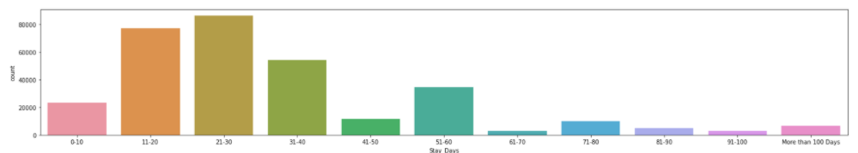
As listed above, there are 3 continuous and 14 categorical variables, without considering the case_id, which is set as an index of the Pandas data frame. Among 14 categorical features, a test of association is performed between Hospital_region and the length of stay of patients, given that COVID-19 patients are could be clustered in high-density population regions. Also, a correlation analysis is performed among all the continuous variables to find multicollinearity problems within the data sets. The findings of exploratory data analysis are outlined in further sections.
Based on the exploratory data analysis on independent and target variables, the data is wrangled so that the machine learning packages can process the data. The Scikit-Learn library’s Ordinal and Label Encoder functions would be mainly utilized to change the string labels into integer encoded values. Also, the lengthy variable names are shortened for ease of coding. The following Python method is used to perform the necessary data wrangling and generate a new Pandas data frame – covid_adj_df. The code for the custom function to wrangle the data is shown below.
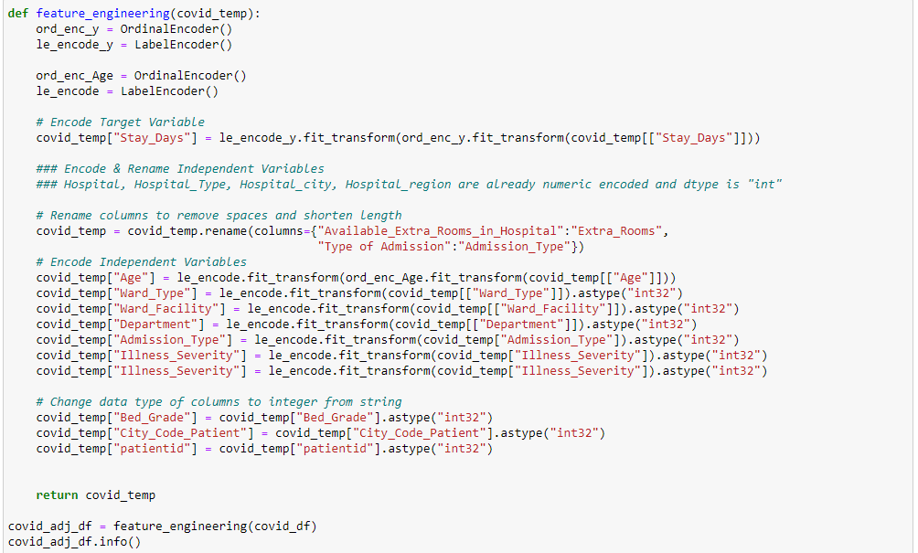
It should be noted that the variables Hospital, Hospital_Type, Hospital_city, Hospital_region variables are already numerically encoded, and type is read as integers, so these variables are not be changed. The outcome of the new adjusted data frame is shown below, along with the top 5 rows from the new data frame.
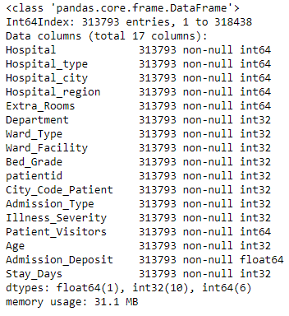
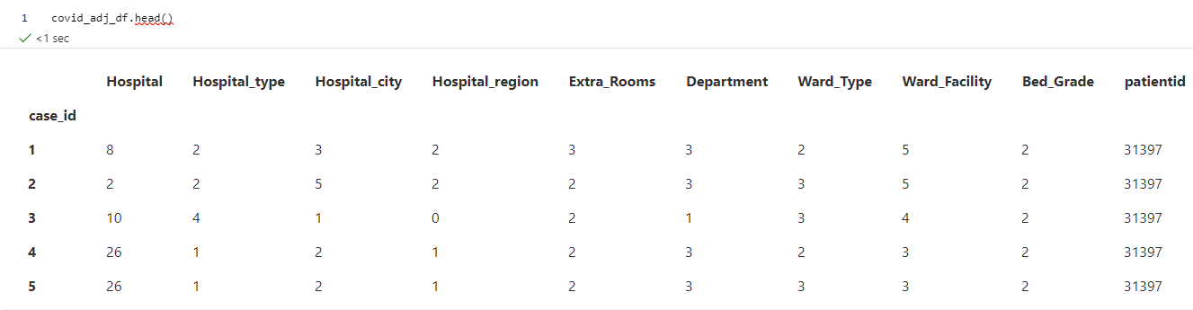
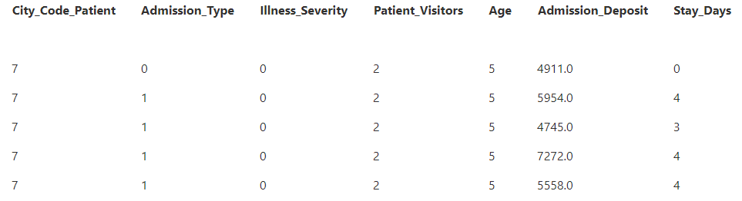

Evaluation Metrics for Imbalanced Classification
The length of the stay response variable is highly imbalanced among all 11 categories. A classifier is only as good as the metric used to evaluate it. Choosing an appropriate metric is challenging generally in applied machine learning but is particularly difficult for imbalanced classification problems. Firstly, because most of the standard metrics that are widely used assume a balanced class distribution, and because typically not all classes, and therefore, not all prediction errors, are equal for imbalanced classification. The following flow chart is used to choose the best metric to use to evaluate the models for the hypothesis testing (Brownlee, 2020).
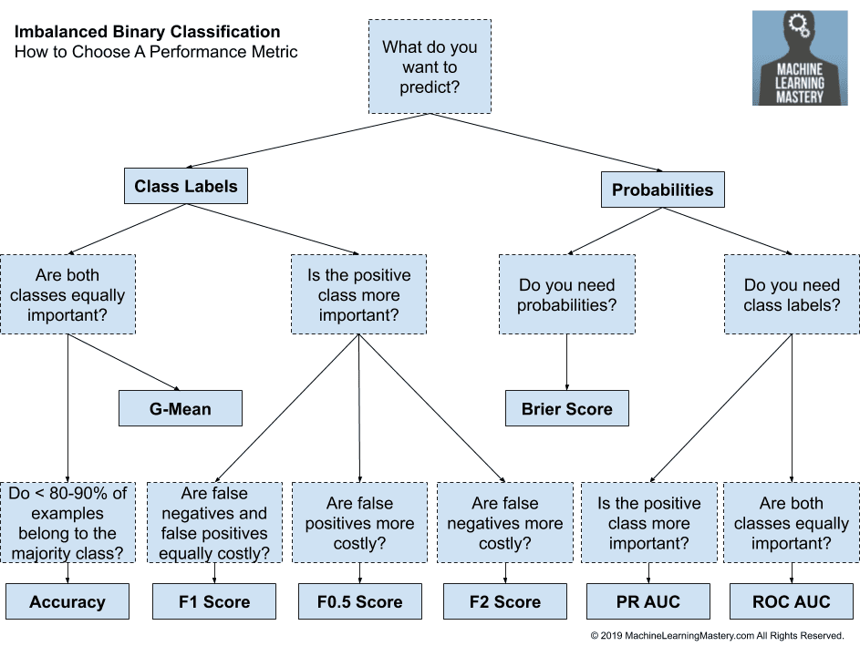
Since the focus is on finding the class with the highest probability for a specific case, and all classes are equally important, the ROC-AUC metric is chosen to evaluate the models.
Another choice for a multi-class classification problem is either go for One-vs-Rest or One-vs-One. Although one-vs-one is generating a greater number of binary classifier models to evaluate, due to the imbalanced nature of the response classes, this approach is chosen to score the metrics of the model (Band, 2020).
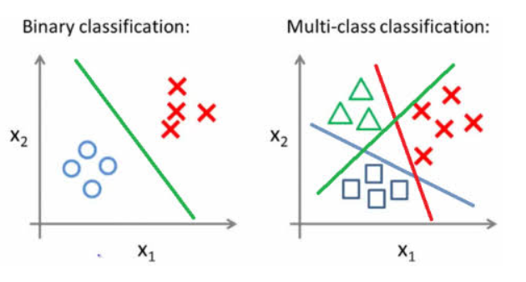
Lastly, using Repeated Stratified K Fold Cross Validation is performed to check the final performance of the model. The procedure is repeated n times, where the data sample is shuffled before each repetition, which results in a different split of the sample (Brownlee, 2020).

Tests of Correlations & Associations
A correlation analysis is performed among all the continuous variables to find multicollinearity problems within the data sets. A combination of corr function from Pandas library and seaborn heatmap visualization is used to find the Pearson correlations among the continuous variables.
Also, a test of association is performed between Hospital_region and the length of stay of patients, given that COVID-19 patients are could be clustered in high-density population regions. First, an association would be checked between each class of hospital region and length of the stay response variable, using the MNLogit function of the “statsmodel.api” package of Python.
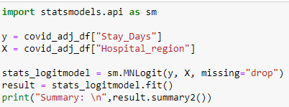
A statistically significant association is found between the region of the hospital and each level of the response variable, a Tukey’s pairwise comparison posthoc analysis is performed using the “pairwise_tukey” function is used from the “pingouin” package in Python to find which regions are most statistically significant for the length of stay of the patients. The advantage of using Tukey’s pairwise comparison is that when doing all pairwise comparisons, this method is considered the best available when confidence intervals are needed, or sample sizes are not equal. The p-values are adjusted according to the Tukey method to keep the overall Experiment Error Rate (EER) to 0.05 significance level (Hotulainen, 2019).

Custom Functions & Honest Assessment
Two custom functions are implemented, one is to plot the ROC-AUC curve for the response classes, and the other is to generate the metrics on predicted data.
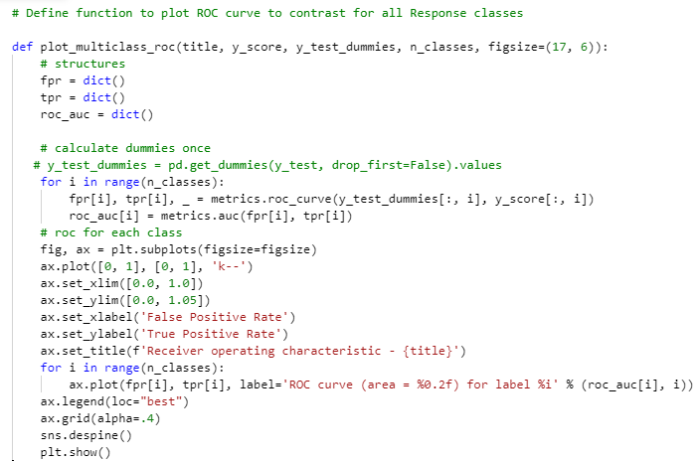
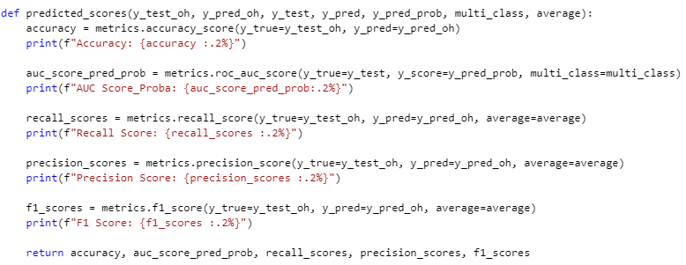
Within the function, the accuracy, ROC AUC, recall, precision, and F1 scores are calculated using the standard Sci-kit learn metrics functions.
To avoid the problem of overfitting of models, a train and test split is done on the data to perform an honest assessment of the models. Using Scikit-Learn’s standard train_test_split function the wrangled data set is split into 80% and 20% for training and validation data respectively. The data is shuffled first to avoid misrepresentation of classes or data (scikit-learn User Guide, scikit-learn 0.24.1).
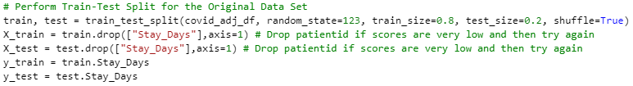

Model Training & Hypothesis Testing
To establish a baseline score, a dummy classifier model is created and a cross-validation score for ROC-AUC is generated on the validation data. This provides a comparison for the baseline Random Forest model created using the training data and helps assess the research hypothesis. If the baseline Random Forest has lower scores than the dummy classifier model, the null hypothesis is failed to be rejected and a Random Forest model cannot be used to classify the length of stay classes, based on the data set provided. Alternatively, if the ROC-AUC scores on the validation data set are better than the dummy classifier model, the null hypothesis is rejected, and the Random Forest model can be used to classify the length of stay of the patients during the admission process. Below is the code to generate the Dummy Baseline Model.
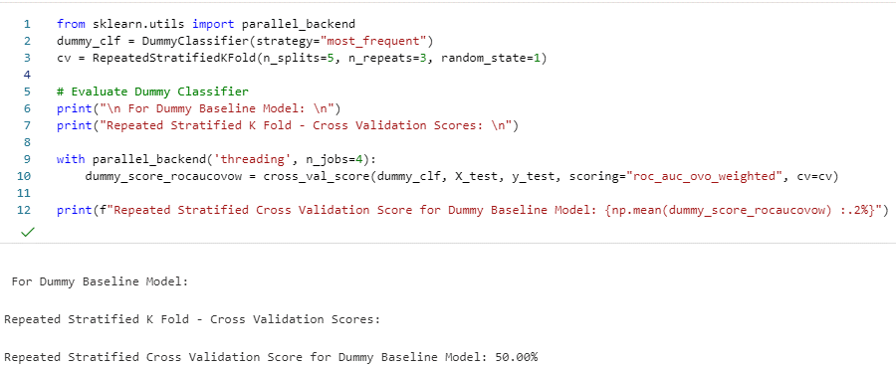
The baseline random forest classification model is generated with all the default parameters to remove any bias for comparison with the dummy classifier model. This means the model generates 100 full depth decision trees. By default, the Bagging or Bootstrap sampling to train the model is switched off in the Random Forest classifier. This option is activated subsequently during hyperparameter tuning if Random Forest is found to generate significantly different results than the dummy classifier.
To avoid memory overruns when fitting the model, due to many records, the “parallel_backend” function from the sklearn library is used to use the multi-threading option instead of default multi-processing execution.
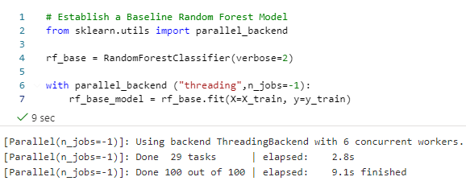
To confirm if the null hypothesis can be rejected, a Repeated Stratified K Fold Cross Validation score is generated. The reason this cross-validation process is chosen because stratification is the process of rearranging the data to ensure each fold is a good representative of the whole. It shuffles the data, after that splits the data into n_splits parts and it is using each part as a test set.
The advantage of this method is that a single run of the k-fold cross-validation procedure may result in a noisy estimate of model performance. Different splits of the data may result in very different results (Brownlee, 2020). However, the disadvantage is that it is resource-intensive to run on the entire data set, especially when the model being estimated is generating multiple full depth decision trees. For this hypothesis testing, cross-validation is performed on the entire data set. But to avoid resource overruns in further instances, the cross-validations are being performed only the validation data sets.

Hyper-Parameter Tuning & Balancing Imbalanced Response Classes
A general approach is to pick the most common parameters, then fit the models with a range of values for each of the parameters, and pick the best estimator among them. Fortunately, the sklearn library has functions such as RandomizedSeachCV and GridSeachCV. One of the approaches is to use the RandomizedSearchCV first and then fine-tune the estimators using GridSearchCV, which is implemented below (Naik, 2020).
Below is the code for RandomizedSearchCV.
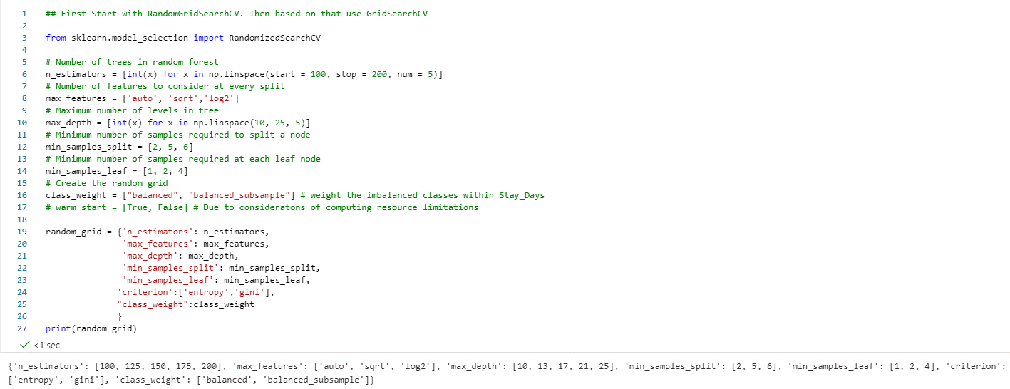
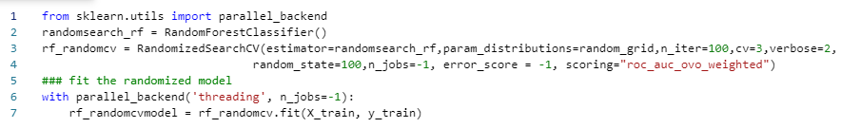
The GridSearchCV function is part of sklearn.model_selection library. The parameters to be set for this systematic cross-validation grid search are shown below. As it can be noted, the Bagging or Bootstrap sampling method is activated during the model fits of Random forest, along with check for Out-Of-Bag (OOB) score validations.
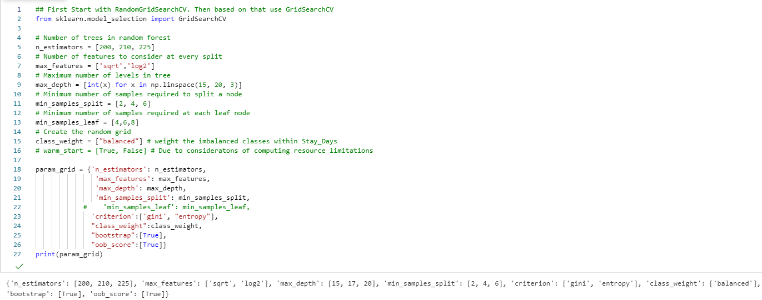
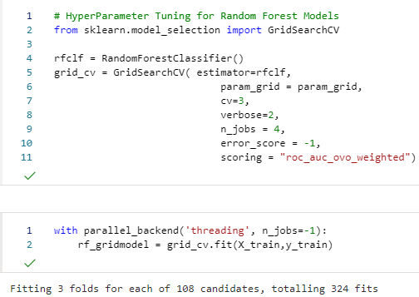
Although Random Forest models are robust against imbalanced response classes, it is imperative to check the performance of the random forest model by either under-sampling the majority classes or oversampling the minority class. In this case, the models with both options are checked. The imblearn or imbalanced-learn Python package provides required functions to meaningfully adjust the sampling of the classes. Here, NearMiss function from imblearn.under_sampling package is used to under-sample the majority class and SMOTE function from imblearn.over_sampling package is used to over-sample the minority classes.
The NearMiss version=3 option selects the closest examples from the majority class for each minority class, and the n_neighbors=3 option selects the 3 nearest neighbors to make the selection. The fit_resample function returns the values for independent and response variables.
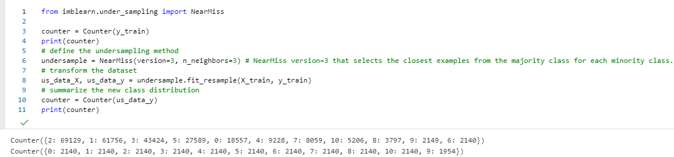
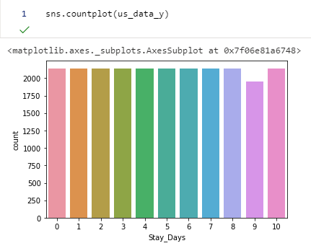
Using SMOTE function from the imblearn package, the sampling strategy selected is auto and k_neighbors=3, which uses 3 nearest neighbors to make the selection. The fit_resample function returns the values for independent and response variables. Using the best parameters from the GridSearchCV, a random forest model is fit on the oversampled training data.
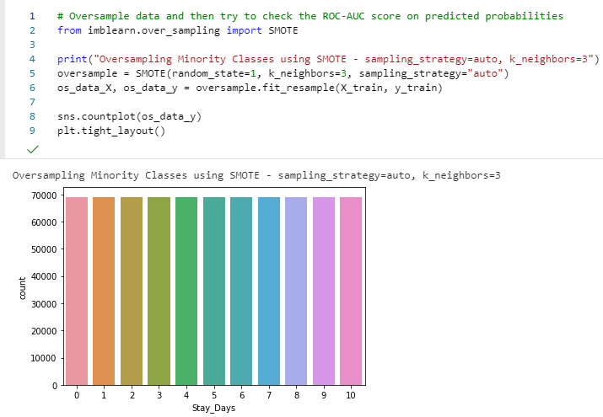

Performance Assessments of All Models
A repeated stratified K fold cross-validation with 5 splits and 10 repeats is performed for each candidate model using the validation data set. Although in practice, the cross-validation is to be performed on the full sample data set, due to resource constraints the cross-validation here is performed only on the validation data set. The code for executing this assessment is below. 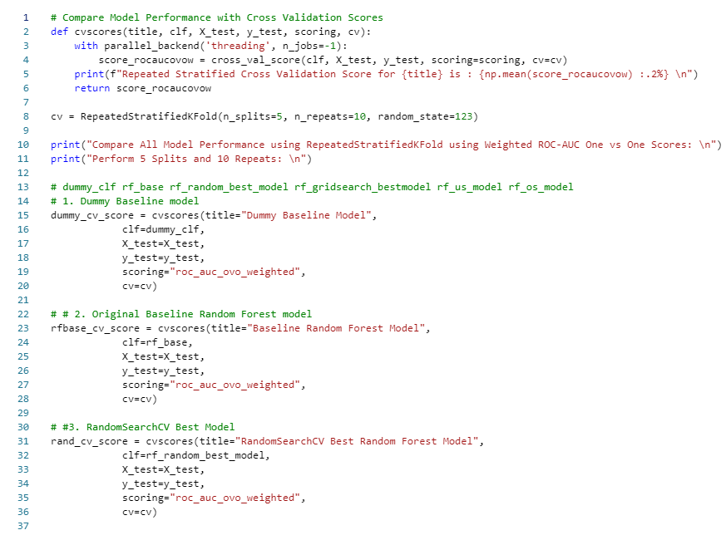

Outline of Findings

Exploratory Data Analysis of Independent Variables
The exploratory analysis of features is performed using dtale, seaborn, and matplotlib libraries.

Target Feature
The above seaborn count plot shows that the classes are highly imbalanced. The Stay_Days class – 21-30 has the highest proportion of entries and the class 61-70 has the smallest proportion of the entries within the response variable. The approach to the model building is addressing this high multi-class imbalance problem.

Independent Features
The value count chart of the Patient_Visitors shows that most patients had 2 visitors, which is a good sign since that limits the chance of infection to visitors. Although there are instances where the number of visitors allowed is greater than 10 through 32 visitors, which could be controlled to curb the number of COVID-19 cross-infections.
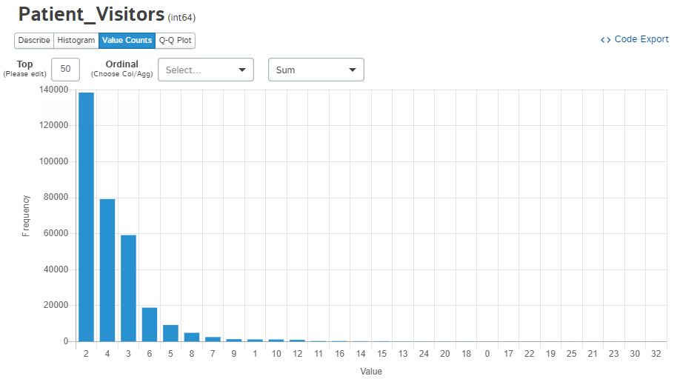
The Admission_Deposit shows an approximately normal distribution. The median deposit amount gathered from the patients is $4,742.
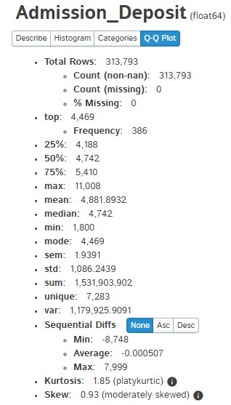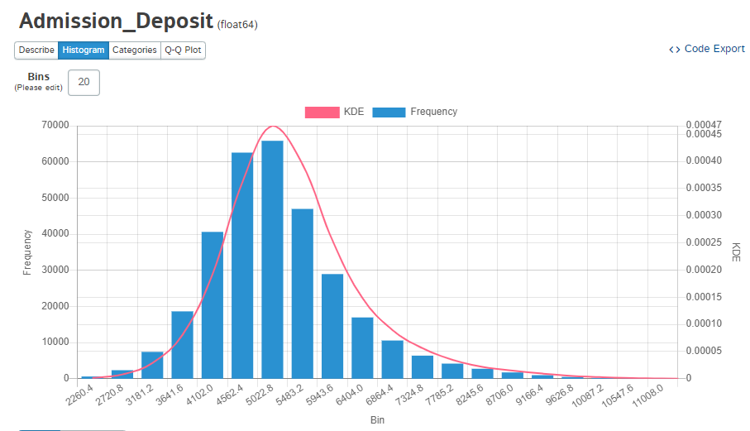
The median number of rooms available at the hospital is 3, which shows that most of the hospitals are running at maximum capacity. Although there are some hospitals with more than 20 rooms available, so the high-volume hospitals could potentially move some patients to those facilities to balance the load of high-volume hospitals. The Available_Extra_Rooms_in_Hospital feature shows that majority of the hospitals have a median availability of 3 rooms, with hospital 11 having the highest median availability of rooms at 4 at the time of admission.
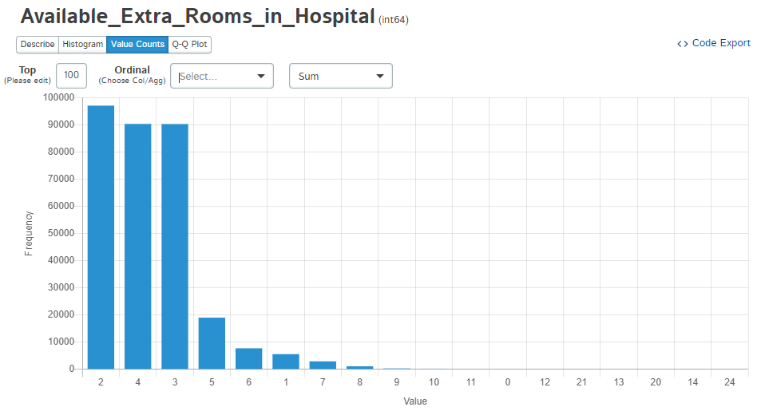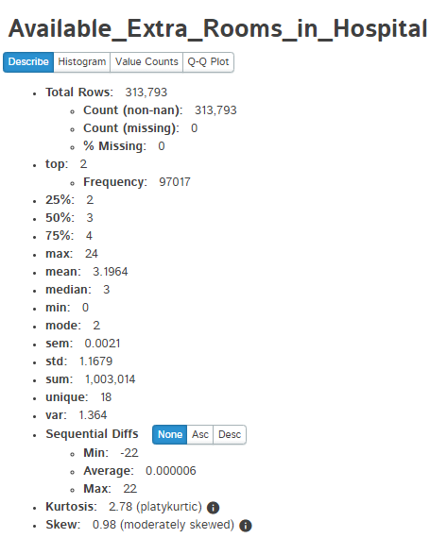
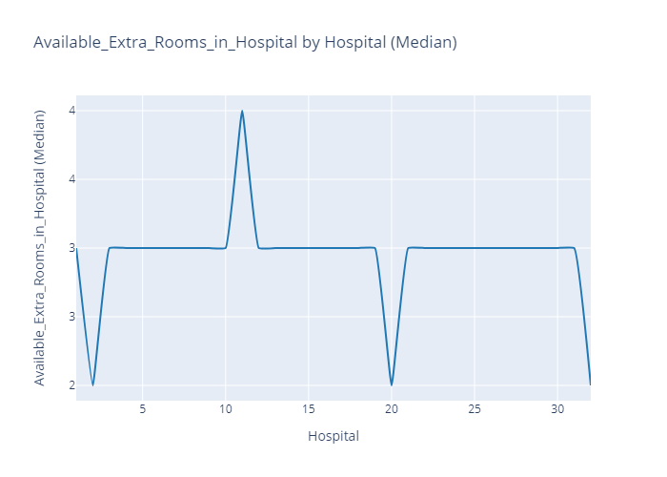
The highest number of patient admissions are happening in hospital 26, followed by hospital 23 and 19 respectively.
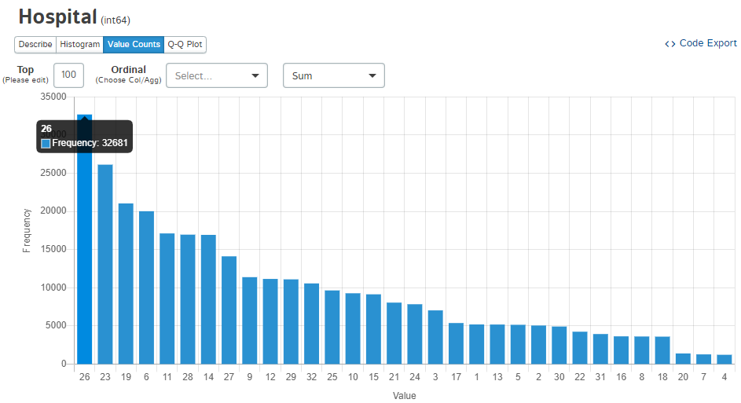
The highest number of patient admissions are happening in hospital type 0 and the lowest admission rate is in hospital type 6.
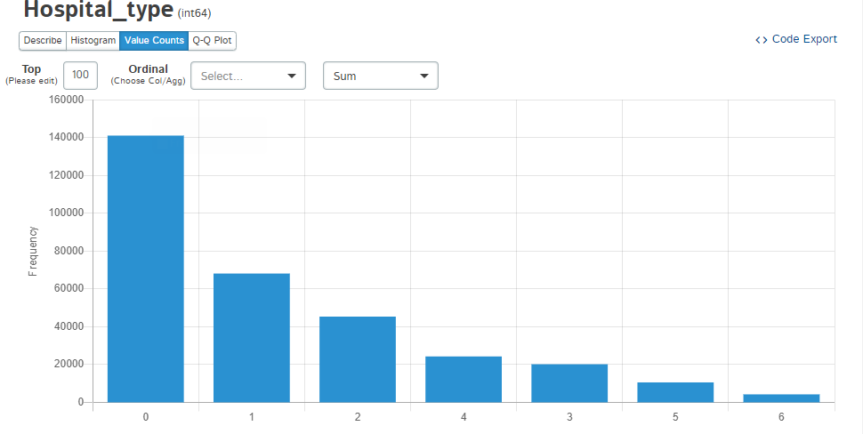
The department feature shows that predominantly the admissions are happening from the gynecology department. This could be either be because a female patient is coming in for their regular checkups or treatments, and as a course of treatment or checkup they are found to be COVID-19 positive and were admitted for COVID-19 treatment. Although without additional patient demographic & medical history details, this cannot be corroborated.
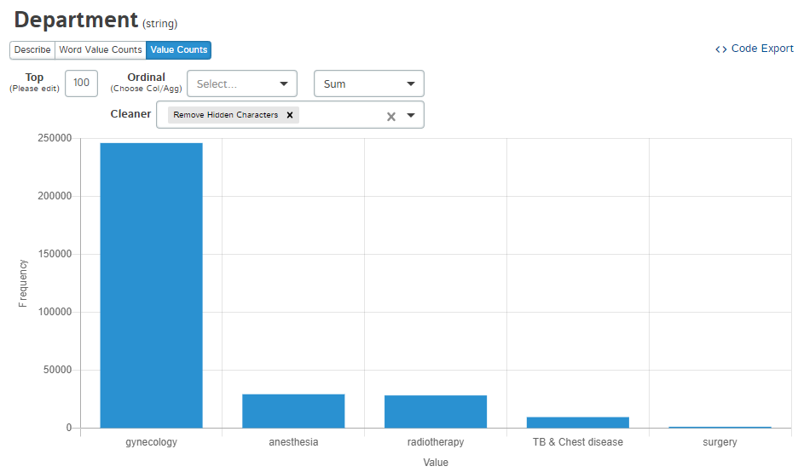
The highest proportion of admission is in the ward type “R”, in the ward facility “F” and with bed grade 2 respectively. The patientID 66714 has the highest number of cases, which could be due to either long-term COVID-19 effects or the patient is getting treated for other severe illnesses on top of COVID-19 symptoms. The City Code Patient code 8 has the highest number of admissions across the hospitals.
The greatest number of patients are visiting Trauma centers, then in Emergency centers. The staff and supplies requirements are heaviest in Trauma and Emergency centers.
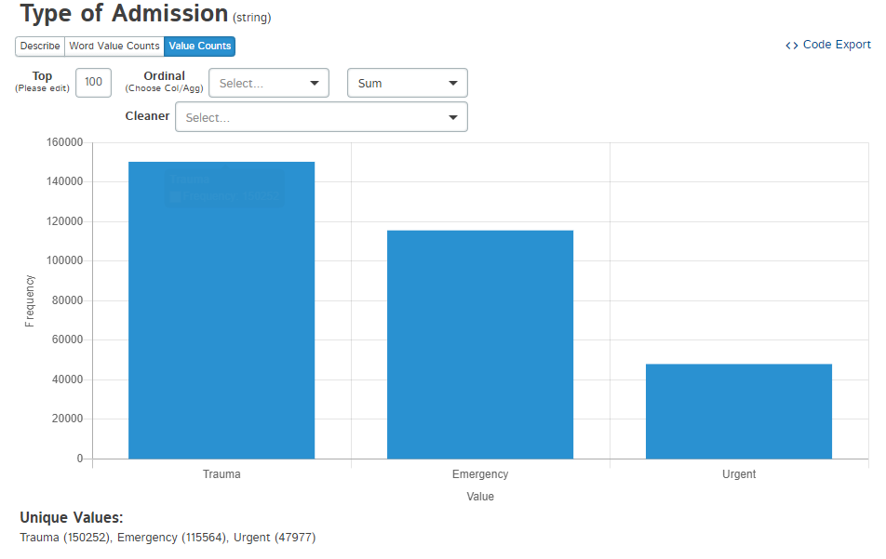
The illness severity could be one of the important factors in providing an insight into the resource demands that a specific case of stay would need. In the case of extreme COVID-19 patients, the precious resources like the ventilators, the nursing staff allocations, and doctors for repeated follow-ups on progress could strain the hospital resources. As can be noted from above, most of the patients admitted to the hospitals are displaying moderate and minor symptoms. Out of 313,793 cases, only 56,049 cases exhibit extreme COVID-19 symptoms.
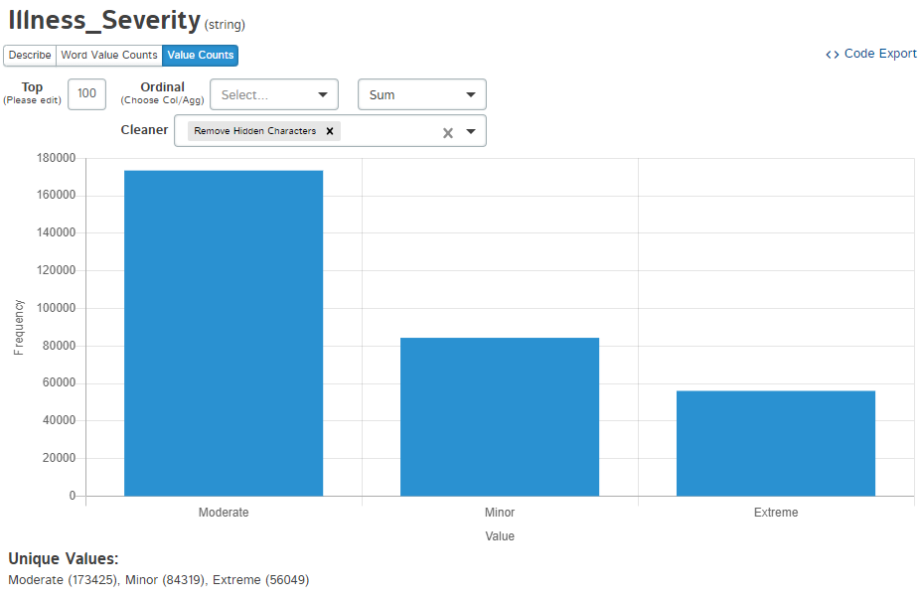
It can be noted that most of the patients admitted with moderate to minor symptoms and stay between 11-30 days.
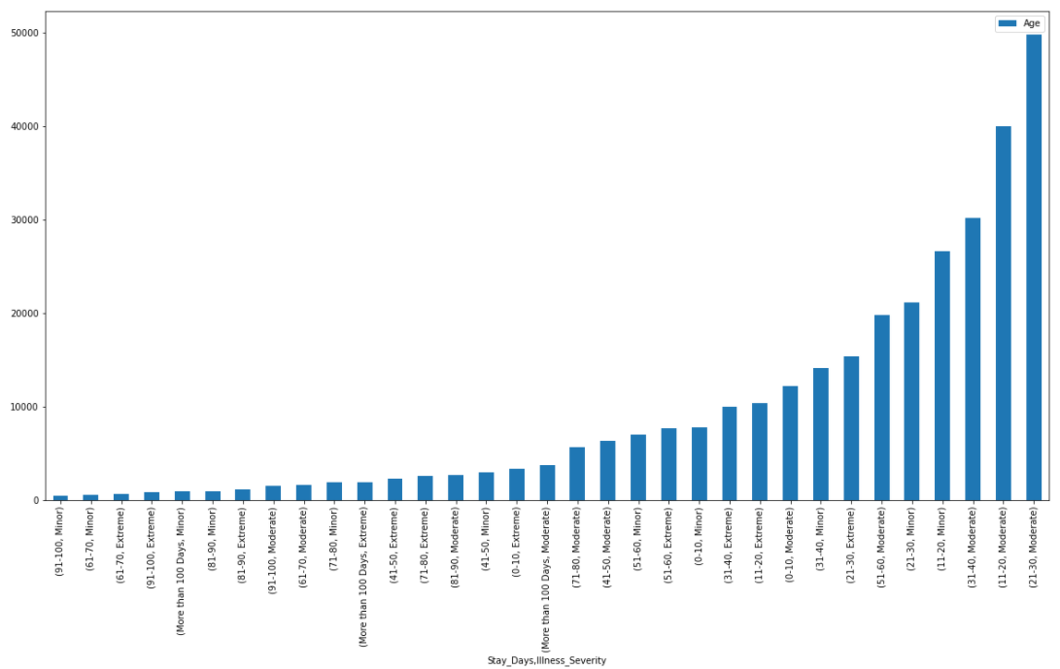

It can be noted that the greatest number of COVID-19 admissions are happening for patients between ages 31-40, followed by patients 41-50. The age ranges from 31-60 make up most of the hospitalization cases among all age groups.

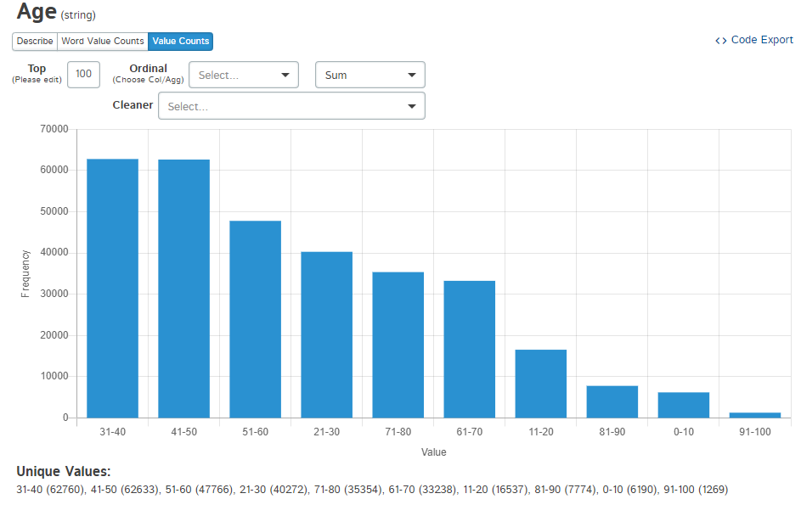
Also, it can be noted that the patients from the age group 31-40 staying between 21-30 days make up the highest percentage of admissions.
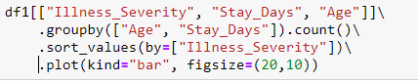
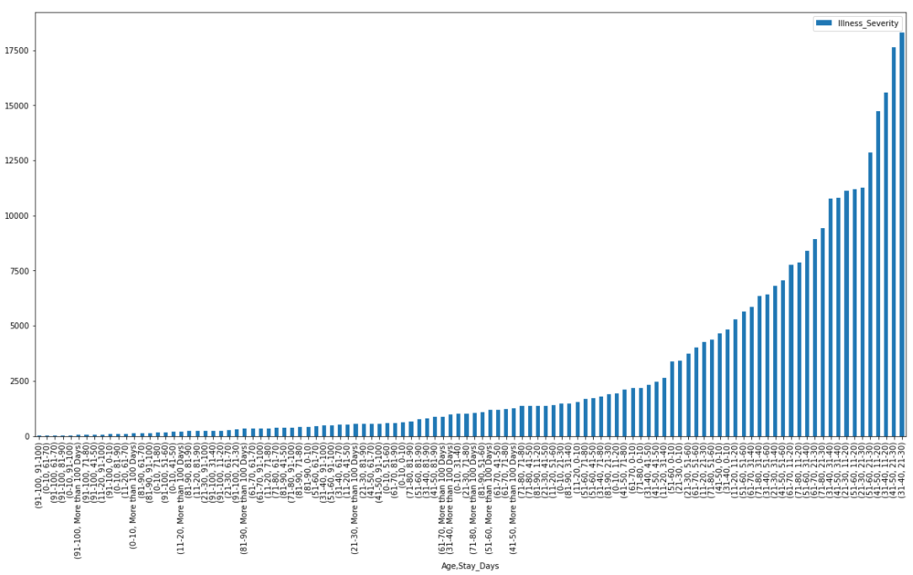
The Hospital_Region has 3 categories, and the greatest number of hospitalizations are from region 0. Hospitals in Region 0 have the highest number of admissions for COVID-19 patients.
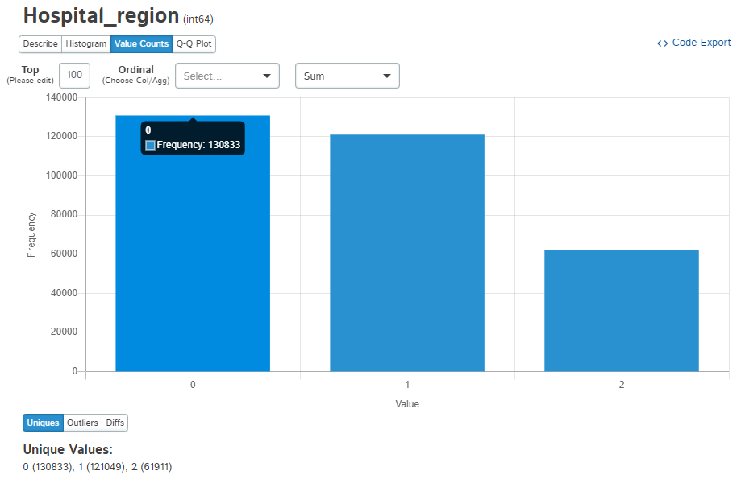
Currently, city 1 has the greatest number of admissions, followed by cities 2 and 6.
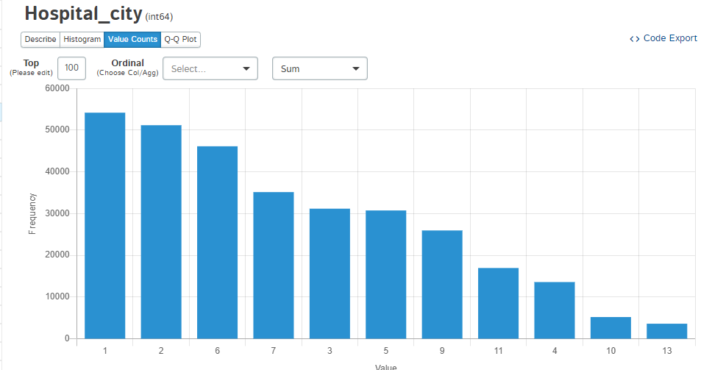
City 1 and 6 belongs to region 0 and city 2 belongs to region 1, which ties with the Hospital_region variable which shows that region 0 and 1 have the highest rate of admission. A follow-up study is crucial to check if the region of the hospital has any relationship to the length of stay of patients. The null hypothesis of this study is that the hospital region does not influence the length of stay of patients, with an alternative hypothesis that at least one region influences the length of stay of patients.
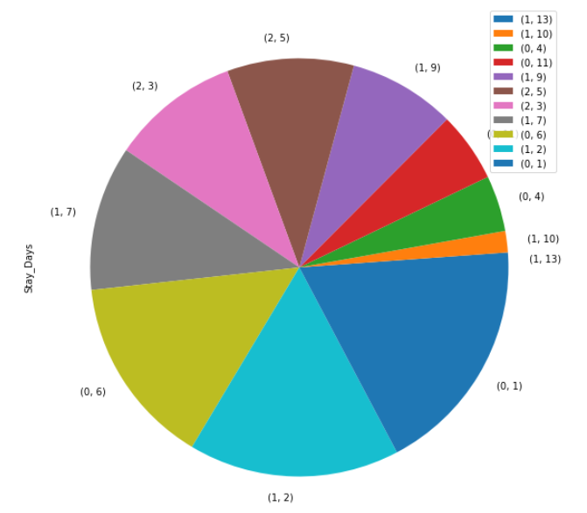

Test of Correlations Among Continuous Variables
As it can be observed, there is very weak collinearity existing between the continuous features.
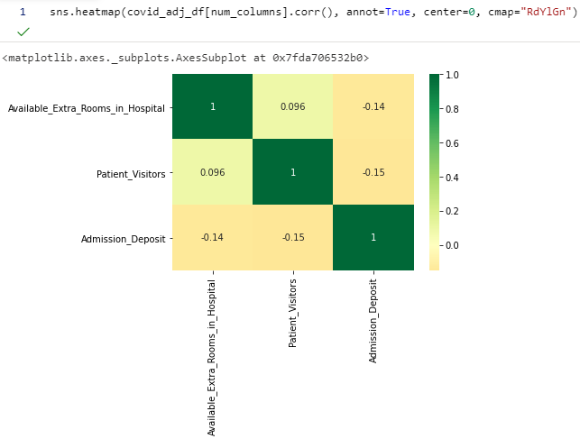

Test of Association Results
The null hypothesis of the test of association study between hospital region and length of stay of patients is that the hospital region does not influence the length of stay of patients, with an alternative hypothesis that at least one region influences the length of stay of patients.
The results of the MNLogit statistic model output show the association of all levels of the Hospital_region variable at each level of Stay_Days. As it can be observed based on p-values for each of the levels of Stay_Days, the Hospital_region is statistically significant at a significance level of 0.05.
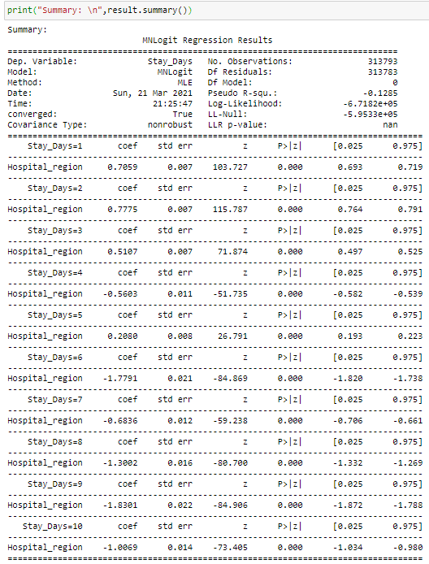
A Tukey’s pairwise comparison posthoc analysis provided additional details on which specific regions among all have the most difference in length of stay. The below table and diagram clearly show that regions 0 and 1, and 0 and 2 are significantly different from each other, whereas regions 1 and 2 are not significantly different in terms of length of stay. The resource management policies can be similar for region 1 and region 2.
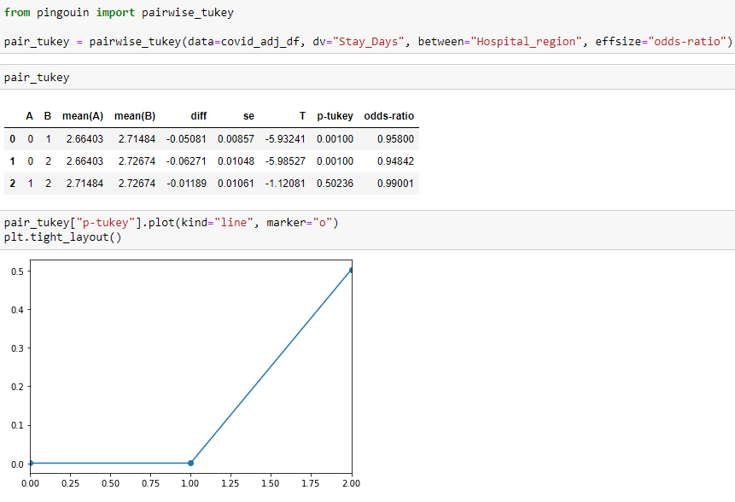

Model Training & Hypothesis Testing
The repeated stratified K fold cross-validation with scoring metric of Weighted One vs One ROC-AUC score for Dummy Classifier model is 50% or 0.5. When AUC is approximately 0.5, the model has no discrimination capacity to distinguish between positive class and negative class, which means either the model is predicting the random class or a constant class (Narkhede, 2021).
The below code and output show the creation of the base multi-class Random Forest classification model and the performance metric scores for the model. As it can be noted, the ROC-AUC score for the predicted probabilities is 76.51% or 0.7651, which is 0.2651 points more than the dummy classifier model.
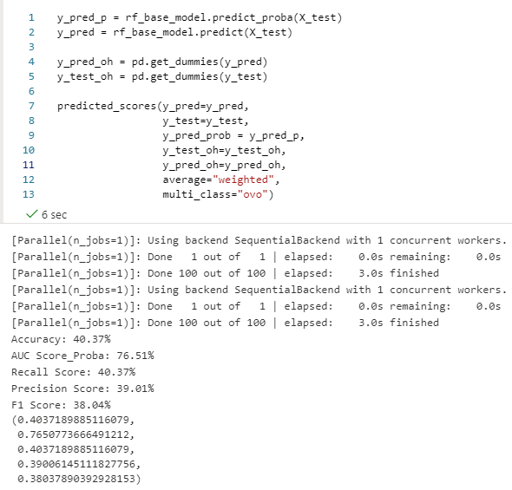
To confirm if the null hypothesis can be rejected, a Repeated Stratified K Fold Cross Validation score is generated. The reason this cross-validation process is chosen because stratification is the process of rearranging the data to ensure each fold is a good representative of the whole. It shuffles the data, after that splits the data into n_splits parts and it is using each part as a test set.
The above code executes the repeated stratified K fold cross-validation on the entire dataset for the baseline random forest classifier. The average weighted One vs One ROC-AUC score for this cross-validation test is 77.08%, which is a 0.57 increase than the single run of the roc_auc_score function.
When compared with the cross-validation score for the dummy classifier, the average weighted one vs one ROC-AUC score for the base Random Forest classifier model is 0.2708 points greater than the dummy baseline model.
This shows that a Random Forest classification predictive model can be built on the data set and the null hypothesis can be rejected in favor of the alternative hypothesis.

Important Features & ROC Curve
Based on the importance score of the base random forest model, the top 3 features are – Admission Deposit, PatientID, and Age.
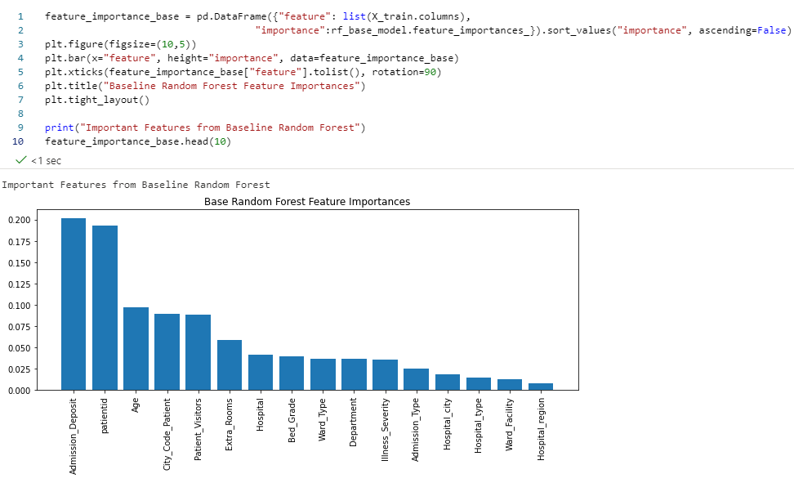
Plotting the ROC curves for each of the response classes provides visual feedback on how each of the response classes is performing at all classification thresholds.
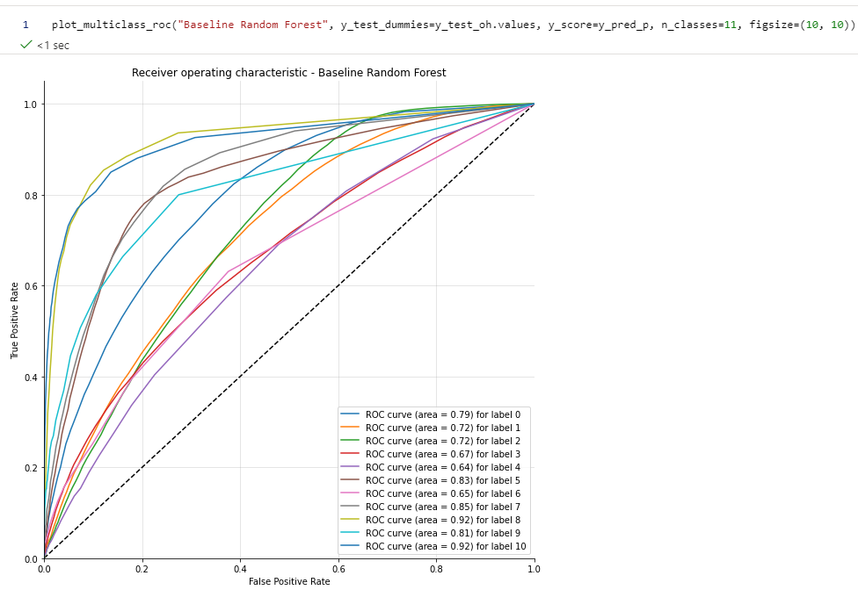

Hyper-Parameter Tuning
The scoring parameter used is the same as used to perform the hypothesis testing, weighted one versus one ROC-AUC score. There are 3 cross-validation folds performed and 100 iterations for each pass totaling 300 model fits. The output best parameters as a part of this execution are shown below. These best parameters are then used to fine-tune them using GridSearchCV next.
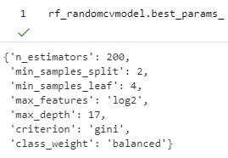
When the best-estimated model is used to check the performance on the validation data, the Weighted OVO ROC-AUC score is 0.7966, which is an improvement from the base random forest model.
The parameters to be set for the systematic cross-validation grid search using GridSearchCV are shown below. As it can be noted, the Bagging or Bootstrap sampling method is activated during the model fits of Random forest, along with check for Out-Of-Bag (OOB) score validations. Based on the 3 cross-validation folds, and 108 unique combinations of parameters, the totaling resulting number of fits is 324. The output is the best parameter values and the best estimator model, based on the training data passed.
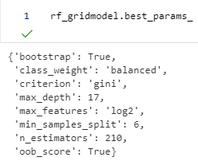
When the best-estimated model is used to check the performance on the validation data, the Weighted OVO ROC-AUC score is 0.7933, which is an improvement from the base random forest model, but slightly less than the random search estimator.

Balancing the Imbalanced Response Classes
Although Random Forest models are robust against imbalanced response classes, it is imperative to check the performance of the random forest model by either under-sampling the majority classes or oversampling the minority class.
Using the best parameters from the GridSearchCV, a random forest model is fit on the under-sampled training data, and the resulting ROC-AUC score is shown below.
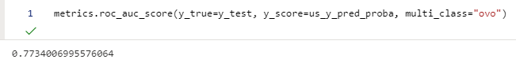
There is a negligible increase in the ROC-AUC score compared to the best estimator of the grid search model.
The resulting ROC-AUC score on validation data for the over-sampled training data is the same as the under-sampled random forest model.

Bottom-line Performance Assessments of All Classification Models
After all the models are fit, choosing the best candidate model for production use would require it to be general enough so it generalizes well on new data, and the performance of predicted probabilities for each response class is also acceptable. Although in practice, the K fold cross-validation is to be performed on the full sample data set, due to resource constraints the cross-validation here is performed only on the validation data set. The average weighted one versus one ROC-AUC score for each of the models is shown below.
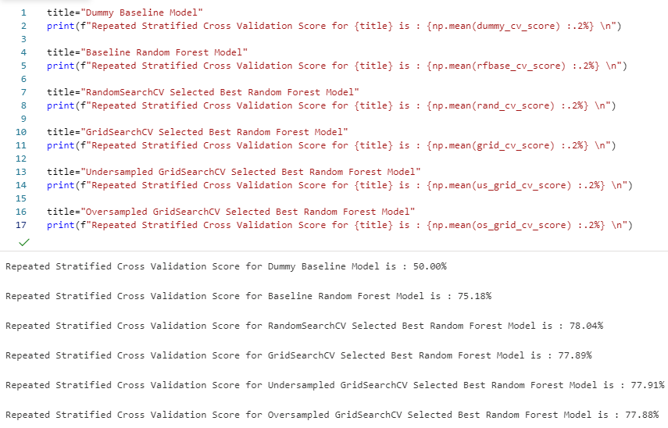
As it can be noted, the best estimator model from RandomizedSearchCV results in the best scores at 78.04%, which is significantly higher than the dummy baseline model at 50%. This model is chosen as a final model for productive use.

Generating Final Output Data Frame
Once the final model is selected, the code to generate the output data frame should also be delivered. The code below generates two output columns, Max_Prob and Pred_Stay_Days_Class. The Max_Prob shows the maximum probability for the predicted length of stay class, displayed under Pred_Stay_Days_Class. This is merged with the validation data frame of independent features, so the entire context of the records can be understood.
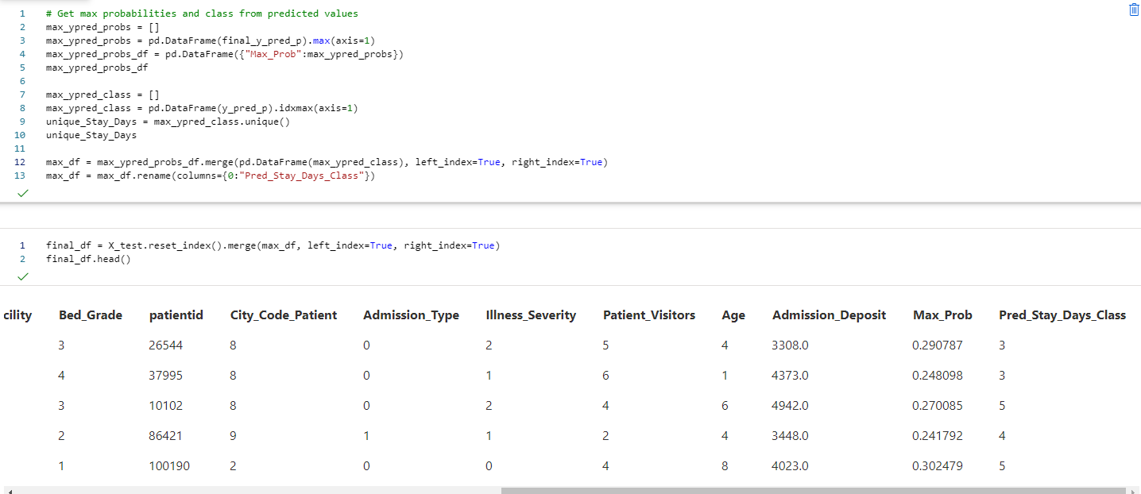
The distribution of classes in the length of stay variable from the validation set can be compared with the predicted classes, which are approximately similar.
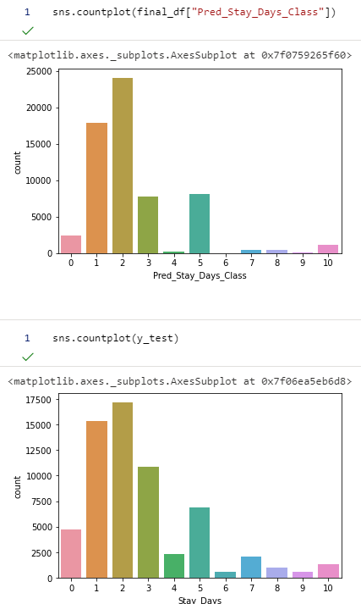

Limitations of the Study
The original data set contains details only about the patient's stay and admission details, but there are no details about the prior health history of the patient, the course of treatment the patient would be receiving, or whether the patient is admitted for COVID-19 treatment earlier or not. The prior health history could greatly influence how the patient would respond to the treatment, which could influence how long the patient would be staying at the hospital.
Another limitation is with the resource constraints put by in-memory and CPU usage of Python’s Scikit-Learn package. Since almost all the processing is done by CPU and memory requirements increase exponentially as the depth of the decision tree, several adjustments to the total number of decision trees generated per random forest model and maximum depth parameters had to be made as a part of hyper-parameter tuning. As a result, the final random forest model for the given data set might not be the most optimal predictive model, and another exercise to fit random forest model using different Python packages which would utilize GPU, increased memory in the environment and CPU resources, and using a different architecture like Spark could be warranted.

Summary of Proposed Actions
Given the limitations of the study, implementing classification models using different algorithms such as Extreme Gradient Boosted (XGBoost) Classification or Neural Networks using different Python packages could be explored. These alternate algorithms could provide better generalization options to fit for imbalanced multi-class response variables.
Another alternative would be to include the patient medical history details along with the stay details, which could provide better insight into how long a patient is going to stay at the facility.
Lastly, as a future enhancement to the prediction process, the final selected model can be saved in a file and deployed through an API to be consumed for predicting individual cases and integrate with other enterprise applications.

Benefits of the Study
The alternative hypothesis of the study is accepted since the weighted One-vs-One ROC-AUC scores for the Random Forest Classifier generated predicted probabilities for multiple classes of the response variable are greater than 0.5, i.e., better than the dummy classifier, which means a multi-class Random Forest classification model can be used to predict the length of stay class of the patient being admitted to the hospital. Using this model at the time of patient admission would provide the details on how long the patient could stay, along with the maximum probability for that prediction, which would give a much better idea on how to allocate the resources optimally for the patient and manage the hospital resources accordingly.
Also, the null hypothesis for the tests of association between hospital region and length of stay was rejected, and the regions 0 & 1 and 0 & 2 were found to be statistically different at significance level 0.05 with a p-value of 0.001. Although regions 1 & 2 were not statistically different with a p-value of 0.5, which is significantly greater than the significance level of 0.05. With this knowledge, the hospital management can generate a regional high-level plan for managing resources for each of the regions. Some regions such as 1 & 2, which are not statistically different from others could leverage similar plans.
Since the alternative hypothesis is accepted in favor of the Random Forest Classifier model, it opens the pathway to exploring advanced classification algorithms and enriching the training data by including the patient medical history, which could further cement the confidence in probabilities for predicting the length of stay of the patient being admitted to the hospital and manage hospital resources optimally during and post-patient admission.

Acknowledgment
The raw data set is obtained from the Kaggle website (Mobius, 2020).
The document template for this report is provided by the Writing Center team from Student Success Centers, with additional details referred to APA style formatting from WGU Knowledge Center (WGU Knowledge Center, solene, "APA Document Formatting", 2018).
All the sources listed under the “References” section of this report were used to refer to details and instructions to complete this analysis and report.
Finally, sincere gratitude to “William Sewell” and “Kelly Smith” for their exceptional guidance, support, and encouragement throughout this course.

References
Data Analytics Graduate Capstone. (2020). TCM2. https://tasks.wgu.edu/student/001101075/course/20280006/task/2649/overview.
Mobius. (2020, November 5). COVID-19 Hospitals Treatment Plan. https://www.kaggle.com/arashnic/covid19-hospital-treatment.
Band, A. (2020, May 14). Multi-class classification - One-vs-all &amp; One-vs-One. https://towardsdatascience.com/multi-class-classification-one-vs-all-one-vs-one-94daed32a87b.
Brownlee, J. (2020, January 14). Tour of Evaluation Metrics for Imbalanced Classification. Machine Learning Mastery. https://machinelearningmastery.com/tour-of-evaluation-metrics-for-imbalanced-classification/
Brownlee, J. (2020, August 2). A Gentle Introduction to k-fold Cross-Validation. Machine Learning Mastery. https://machinelearningmastery.com/k-fold-cross-validation/.
Sankara. (2018, June 21). How handling of missing values affects Model Accuracy. https://medium.com/@SankaraJ/how-we-handle-missing-values-affects-the-accuracy-of-machine-learning-models-c120310141b5.
Ozen, B. (2017, March 6). Multi-class Classification on Imbalanced Data using Random Forest Algorithm in Spark. https://www.linkedin.com/pulse/multi-class-classification-imbalanced-data-using-random-burak-ozen/.
Malik, U. (2018). Random Forest Algorithm with Python and Scikit-Learn. https://stackabuse.com/random-forest-algorithm-with-python-and-scikit-learn/.
BurtchWorks. (2020, December 17). 2020 SAS, R, or Python Survey Results: Which Tool do Data Scientists & Analytics Pros Prefer? https://www.burtchworks.com/2020/12/16/2020-sas-r-or-python-survey-results-which-tool-do-data-scientists-analytics-pros-prefer/.
Plonski, P. (2020, June 24). How to reduce memory used by Random Forest from Scikit-Learn in Python? MLJAR Automated Machine Learning. https://mljar.com/blog/random-forest-memory/
statsmodels User Guide. (2021, February 2). MNLogit. https://www.statsmodels.org/stable/generated/statsmodels.discrete.discrete_model.MNLogit.html
pingoouin User Guide. pingouin.pairwise_tukey. pingouin.pairwise_tukey - pingouin 0.3.10 documentation. https://pingouin-stats.org/generated/pingouin.pairwise_tukey.html#pingouin.pairwise_tukey.
scikit-learn User Guide. scikit-learn 0.24.1. sklearn.model_selection.train_test_split. https://scikit-learn.org/stable/modules/generated/sklearn.model_selection.train_test_split.html.
Narkhede, S. (2021, January 14). Understanding AUC - ROC Curve. Medium. https://towardsdatascience.com/understanding-auc-roc-curve-68b2303cc9c5.
Naik, K. (2020, July 23). All Hyperparameter Tuning Techniques. https://www.youtube.com/watch?v=355u2bDqB7c&amp;ab_channel=KrishNaik. ------- (Naik, 2020)
Hotulainen , R. (2019). Multiple-Comparison Procedures. https://www.mv.helsinki.fi/home/hotulain

